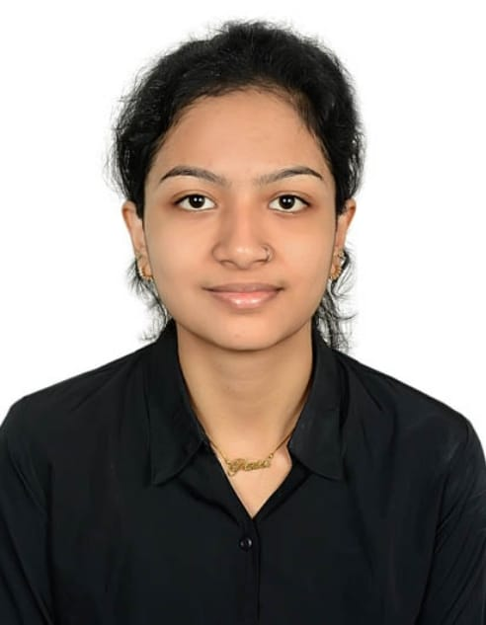**RESUME**

**PAREENITA ATUL SHIRSATH**

➢ **PERSONAL INFORMATION** :

• Email – pareenitashirsath99@gmail.com

• Contact - 8811223344

• Address - Kalamboli , NaviMumbai.

1. Date of Birth – 7th December, 2004

2. Marital Status - Unmarried

3. Languages known - English, Hindi, Marathi.

➢ **OBJECTIVE:**

To work efficiently and effectively as well as grow with a prestigious organization in the field of Artificial Intelligence and Data Science Engineering, so as to achieve self-realization and the accomplishment of organizational goals

➢ **EDUCATIONAL QUALIFICATION**:

Bachelor of Science in Artificial Intelligence and Data Science

Mumbai University , Kharghar,Maharashtra

[November 2022] – [June 2026]

Relevant coursework: Data Structures, Algorithms, Database Systems, Software Engineering

➢ **EXTRA-CURRICULAR ACTIVITIES:**

1.Worked in an TPO committee.

2. Completed programming course on coursera about C, C++, JAVA and Python.

3. Video editing and Photo editing .

➢ **PROJECTS:**

1. BRAINUP APP .

2. PLANT DISEASE DETECTION.

➢ **SKILLS :**

1. Good communication skills.

2. Good presentation skills.

3. A quick learner.

➢ **HOBBIES:**

1. Volunteering for causes.

2. Making artistic items.

3. Sketching

4. Dancing, Swimming

➢ **DECLARATION :**

I hereby declare that the above-mentioned information is genuine and true to the best of my knowledge.

Place:Kalamboli,Navimumbai.

Date:20 September,2024.

Pareenita A.Shirsath